Super Set ID: 6125132
Name: P. Vinay Kumar
Week :5
Eureka Discovery Server and Microservices Setup
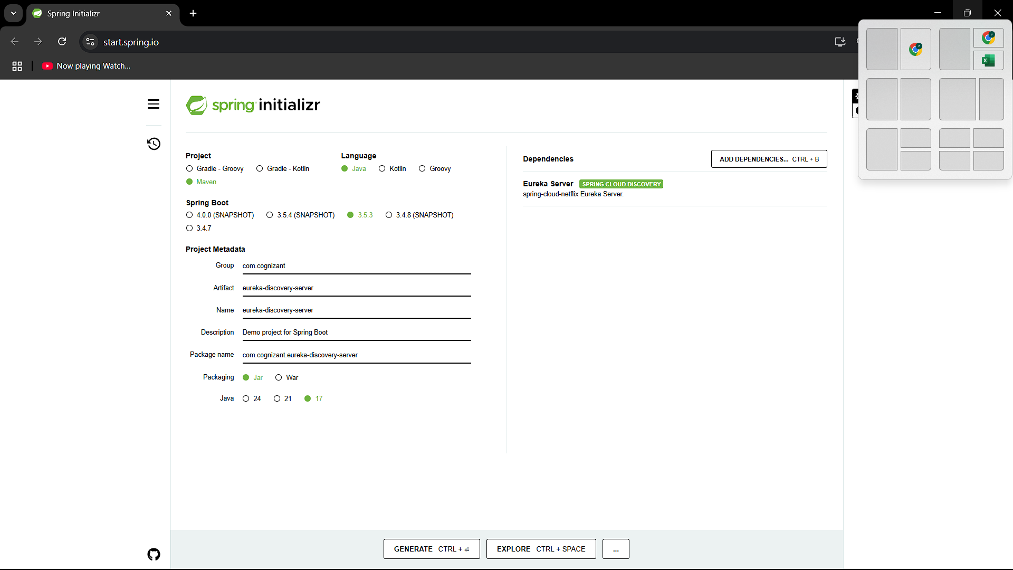

application.properties:
server.port=8761
eureka.client.register-with-eureka=false
eureka.client.fetch-registry=false

logging.level.com.netflix.eureka=OFF
logging.level.com.netflix.discovery=OFF

EurekaDiscoveryServerApplication.java
package com.cognizant.eureka;

import org.springframework.boot.SpringApplication;
import org.springframework.boot.autoconfigure.SpringBootApplication;
import org.springframework.cloud.netflix.eureka.server.EnableEurekaServer;

@EnableEurekaServer
@SpringBootApplication
public class EurekaDiscoveryServerApplication {
public static void main(String[] args) {
SpringApplication.run(EurekaDiscoveryServerApplication.class, args);
}
}package com.cognizant.eureka;

import org.springframework.boot.SpringApplication;
import org.springframework.boot.autoconfigure.SpringBootApplication;
import org.springframework.cloud.netflix.eureka.server.EnableEurekaServer;

@EnableEurekaServer
@SpringBootApplication
public class EurekaDiscoveryServerApplication {
public static void main(String[] args) {
SpringApplication.run(EurekaDiscoveryServerApplication.class, args);
}
}

2. Account Service

application.properties :
spring.application.name=account-service
server.port=8080
eureka.client.service-url.defaultZone=http://localhost:8761/eureka

AccountApplication.java :
package com.cognizant.account;

import org.springframework.boot.SpringApplication;
import org.springframework.boot.autoconfigure.SpringBootApplication;
import org.springframework.cloud.client.discovery.EnableDiscoveryClient;

@EnableDiscoveryClient
@SpringBootApplication
public class AccountApplication {
public static void main(String[] args) {
SpringApplication.run(AccountApplication.class, args);
}
}

AccountController.java :
package com.cognizant.account;

import org.springframework.web.bind.annotation.*;
import java.util.*;

@RestController
public class AccountController {
@GetMapping("/accounts/{number}")
public Map<String, Object> getAccount(@PathVariable String number) {
return Map.of(
"number", number,
"type", "savings",
"balance", 234343
);
}
}

3. Loan Service:
LoanApplication.java:
package com.cognizant.loan;

import org.springframework.boot.SpringApplication;
import org.springframework.boot.autoconfigure.SpringBootApplication;
import org.springframework.cloud.client.discovery.EnableDiscoveryClient;

@EnableDiscoveryClient
@SpringBootApplication
public class LoanApplication {
public static void main(String[] args) {
SpringApplication.run(LoanApplication.class, args);
}
}

LoanController.java :
package com.cognizant.loan;

import org.springframework.web.bind.annotation.*;
import java.util.*;

@RestController
public class LoanController {
@GetMapping("/loans/{number}")
public Map<String, Object> getLoan(@PathVariable String number) {
return Map.of(
"number", number,
"type", "car",
"loan", 400000,
"emi", 3258,
"tenure", 18
);
}
}

